**Required Document for Talk Box**

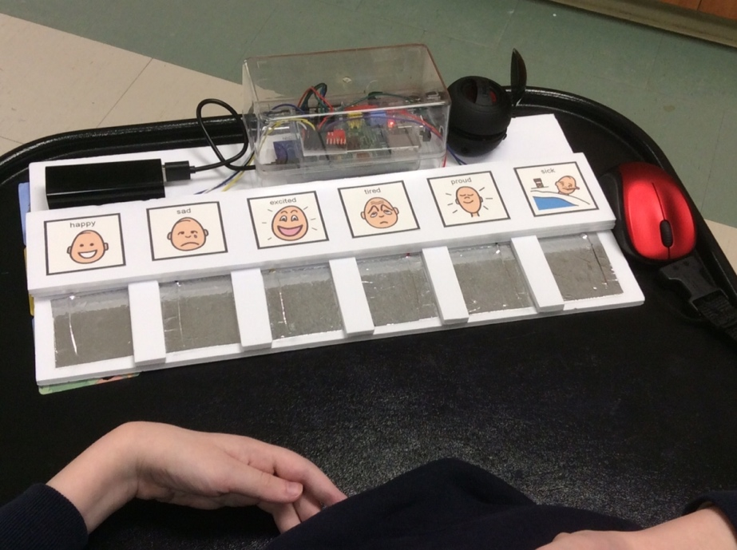

**Table of Contents:**

# Introduction 3

# Needs of the User 4

# Required Features 5

# UAT (User-Acceptance-Testing) 7

# References 9

**Introduction:**

Speech and hearing disabilities affect a larger majority of our society than most people are aware of. In fact, approximately 10% of the general population, 20% of those over age 65 and 40% of those over age 75 have a significant hearing issue. Although that 10% doesn’t sound like a lot it actually means that there are 360,000 people in Canada alone that are affected by speech and hearing impairments. These issues are not only prevalent in elderly individuals as an estimated 4% of children attending preschool have a substantial speech disorder. Common verbal communication disorders in children include articulation disorders, voice problems such as volume and pitch, stuttering issues, and language difficulties. Therefore, it is clear speech and hearing impediments are increasingly prominent and require adequate aids for accessibility.

Assistive devices are those that help individuals with hearing or speech disorders communicate. These devices primarily aid in hearing and comprehending what is being said more clearly, but not enough devices assist with conveying expressions of thoughts.

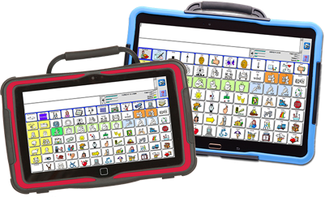There are three main types of devices health professionals use, including assistive listening devices (ALDs), augmentative and alternative communication (AAC) devices, and alerting devices. ALDs focus on amplifying sounds when there is a lot of noise in the background and can be used in conjunction with a cochlear implant or hearing aids. AACs help those with communication impairments express themselves better through the use of either picture boards or computer programs that can synthesize speech from text. Lastly, alerting devices are connected to household items like phones, doorbells, alarms, that emit loud sounds or bright, blinking lights. This helps individuals with hearing loss become aware of events like someone ringing their doorbell or calling their phone.

Specifically, in this case, AAC devices that assist those with communication disorders consist of a picture board that uses images or symbols of general items that compose one’s daily life. Unfortunately, there aren’t enough adequate AAC devices for those affected so they tend to have several disadvantages. Not only are they overly complicated but they also fail to meet user requirements and can also have a low retention rate. They require a great length of time to master how to use it correctly, which can cause others who interact with the user to take time learning how to interpret it correctly. These AAC devices are generally bulky and very expensive, running up to almost $6000 to $11,500 each which doesn’t include the cost of the mounting bracket on the back that attaches it to a post. These cons result in users not liking the devices due to their complicatedness and stop using them altogether. But, the Talk Box is here to fix all of that!

**Needs of the User:**

Many individuals possess a varying range of speech and hearing issues including stutters, the loss of hearing, the inability to speak and several others which may cause them to be at a disadvantage when attempting to communicate with others. For such individuals, having an assistive device to aid in their communication abilities is crucial to their functioning and socialization.

The average user with the previously described impairments may need assistive devices and methods that can emulate speech for them to allow appropriate communication. Such users may need the device to be very simple and basic to use since their motor functions many not necessarily be fully intact. For example, some individuals with speech impediments or hearing issues may also have shaky hands or other tremors related to functionality. These issues would hinder one’s usage of keyboards since unsteady hands may not be as efficient when typing words quickly. For this reason, the individual may require a device with large separated buttons so that messages can be conveyed through the push of a single button rather than having to meticulously type out entire words.

Furthermore, the simplicity of the device should allow a wide range of individuals to be able to use it, specifically between the ages of 5 to at least 70. It should not be overly complicated or daunting for individuals to use and have minimal technologically advanced concepts. This simplicity will allow all users to communicate smoothly and efficiently without confusion or hiccups.

It is common for individuals with impairments to become frustrated since they have less control over their communication. It is very easy for them to get upset with their limitations. So, users may want autonomy and freedom to express themselves through their messages for which a customizable device would be very useful. Customizability can include the option to use their own words, phrases, and slang terms so that they can sound more like themselves and showcase their individuality.

Additionally, individuals may feel like their impairment is preventing them from communicating fluently and at an appropriate speed. So, they may need a device that is quick at delivering the required messages. This fast delivery will allow users to convey their messages in a speed that is relative to the pace of the conversation and matches the tempo of the other person.

Those with speech and hearing impairments may also find difficulty in communicating with those who are at a distance. For example, those with speech impairments such as stuttering, apraxia, or dysarthria may find it hard to speak quickly or coherently due to their weak speech muscles and brain damage. For these individuals, having a device where the audio has a strong range of volume and is even adjustable is incredibly important. This would also give them the ability to talk in quieter areas like libraries or large social gatherings without standing out and feeling awkward since they will have the option to adjust volume accordingly.

Individuals with impairments don’t typically enjoy feeling like they are wildly different from others in society, and mainly want to exist just as anyone else in the community. Feeling like they are treated differently is something they generally aren’t fond of and can cause them to feel ostracized. Due to this, they choose to conduct their days in a very typical, routinely format. They are mobile, going from place to place and do not want to be slowed down by having to carry around a bulky assistive device. Having a lightweight, portable communication device will allow them to continue conducting their days as productive members of society.

Since assistive devices are relied upon quite heavily, impaired individuals may need a very dependable device that will not break down during communication. The device should be functional and should not have battery issues or accidental unplugging mishaps.

**Required Features:**

The assistive devices used by individuals with speech or hearing impairments should have certain features that can help make communication easier and overall more efficient.

The device should have at least 12 selectable buttons when initially launched; having a minimum of 12 buttons gives a reasonable amount of variety to begin with, and a customizability option would further that notion. These initial 12 buttons should be pre-set options allowing individuals to familiarize themselves with the environment if they so choose and get a feel for the style of the device along with how it works. Having pre-set options of words and phrases will ensure that users do not have to spend a lot of time manually inputting the buttons one by one which can become daunting at first.

Users should be able to select the audio output of each button if they choose to change it. This should be done by allowing the user to upload personalized audio files in accordance with the individual’s typical speaking patterns such as slang terms, common phrases, and everyday words to bring out the user’s individuality. This way, individuals can simply play their own audio from the buttons rather than being confined to the default audio messages allowing the device to account for incorporating the user’s personality.

The text display of the buttons should also be customizable by allowing users to change the labels of each button, altering its text to better suit their creative choice of words and characters.

Users should be able to change the image associated with each button through an option to upload an image for each button. This will allow them to customize each button thoroughly so that it better suits their preferences.

Although the devices start with 12 buttons the user should be allowed to add or remove any number of buttons. For each added button, the user should be able to customize the button label, button audio, and the button image allowing the user to represent any word, phrase, or emotion they choose and display it in any fashion they prefer.

Another required feature should be the categorization of the words and phrases by categorizing the buttons. Grouping the buttons together will lead to increased efficiency by saving time during communication since users will be able to navigate through the catalogue of words and phrases quicker that looking in a jumble of buttons. The ability to deliver messages at an appropriate speed is also an important feature to incorporate since the users will be able to convey their messages at an adequate pace.

The device should also be generally simple to use with limited complications that may lead to confusion regarding its operation and function. There shouldn’t be too many buttons and it should be designed so that users aged 5 to 70 should be able to use the device.

Devices should be lightweight rather than heavy and bulky to allow portability from place to place. Devices should also be sturdy, durable and functional so that they do not break down or malfunction during the user’s communication. This will allow users to proceed with their day to day lifestyles without having to be concerned about paying close attention to their assistive devices while also having durability in its design. It will also assist the fluency and smoothness of their communication to ensure it is conducted with ease so the user does not have to be bothered about keeping tabs on the device.

Another feature that should be included is adjustable volume so that users can talk from far distances and at varying volumes depending on their surroundings.

Users should be able to save their previously configured settings as a file so they do not have to keep setting it up from the very beginning every time they want to use it. This will avoid meticulously having to restart the process of setting up the device and will allow for speed in communication since previous settings will be saved.

The device should be affordable so that it is easily accessible for users of most socioeconomic statuses. A reasonable price range for such a device should be around $70 to $100. This way, most individuals with speech or hearing impairments will be able to obtain the device easily without having to break the bank.

The device should also be appealing to the users since they will be carrying it around with them almost everywhere they go. Since it will eventually play a large role in their everyday lives, it should have a simple, sleek design and it should be offered in a range of colours so promote individuality and self-expression.

Another feature of the device should to be the “Log App”. This feature should be visible only when the configuration for the device is opened. The Log App feature should be able to display a record for all the various things that the user did while on the app. Each record/log of an action being done should have the time of action, the actual name of the action, and which aspect of the device the action was taken on. For example, whether it was during set up (Configuration App) or during the Device use. This feature is needed so that developers can know which of the configuration features are used most often (change button images/audio, adding/removing new buttons, adding/removing categories of buttons, etc.) and with this knowledge they will know better as to which features to focus working on. Also keeping a record of which buttons the user uses on the actual Talk Box device will also be helpful because then the person setting up the device (either the support worker helping the user or the user themselves) can have a better idea of which audio buttons are being used and which aren’t in order to better optimize which audio buttons should be kept.

**UAT (User-Acceptance -Testing):**

Each of the required features must be tested to see if it is up to users’ standards and can effectively function as per its requirements. The first feature is the 12 pre-set selectable buttons the device initially comes with. This can be tested by observing whether the user is able to use all 12 buttons without having to configure anything. Since these 12 buttons are the default items the device contains upon starting it up, they should function optimally and with ease.

The ability to customize a button’s audio, labelling text, and display image can all be tested by attempting to change each of those characteristics for each of the 12 default buttons. The trials for each audio, text, and image customization should be repeated at least 5 times for each button and the length of time to complete the customization should be recorded. The features pass the test if the customizability of a button’s audio, text, and image can be conducted successfully in every trial for all 12 buttons.

The ability to add or remove any number of buttons can be tested by a series of trials. First, the device must be launched after which one will be able to view the 12 default buttons. Then, 100 buttons should be added each with functioning audio, text, and images. Then one must remove all the 100 buttons that were added so that the initial 12 default buttons are remaining. The feature passes the test if after removing the 100 added buttons, the initial 12 default buttons are left and the device is identical to what it looked like upon its preliminary launch.

The next feature, categorizing the words and phrases, can be very easily tested through launching the device and observing if similar buttons are grouped together into categories. For example, all buttons pertaining to a given emotion should be in one category for easier access. The feature passes the test if upon launching, the buttons are already grouped without any configuration involvement on behalf of the user.

The speed with which the messages are delivered can be tested in three parts. The first trial will record the length of time it takes for an unimpaired individual to say one of the pre-set phrases. The second trial will record the length of time it takes for an impaired individual to say the same pre-set phrases using this device. The third trial will record the length of time it takes for an impaired individual to say the pre-set phrases using a competitor device in the market. The feature will pass the test if the recorded speed of the second trial is on par with the competing device or higher. The purpose of the first trial is to compare speed and gain perspective of speed relative to verbal speech.

The simplicity of the device can be tested through a focus group containing 100 impaired individuals aged 5 to 70 to determine the ease of usage. Prior to the focus group, predetermined tasks for using the device will be set. In the focus group there will be an informational session where the individuals will be taught how to use the device. Then, they will all be given the same predetermined tasks to complete on the device and the length of time spent completing the tasks will be recorded. Potential tasks include asking the individuals to click Button One, or to select a given category. The feature will pass the test if the individuals are able to complete the tasks quickly as it will indicate simplicity of navigation and ease of usage.

To test if the device is lightweight and portable, 100 impaired university students will be recruited. They will be required to carry the device around with them for two weeks instead of their laptops. Whether it was equally convenient or difficult to carry will be observed and reported. The feature will pass the test if the individuals report that the device was convenient, lightweight, and easy to carry around.

To test if the device frequently breaks down, glitches, or malfunctions during communication, 100 impaired individuals will be recruited. They will be required to communicate using the device for six months. At the end of the six months, the devices will be returned and the individuals will be required to report how many times they had malfunctions and other technical issues. The test will be successful if users report little to no functionality issues, indicating that communication went smoothly through the use of the device.

The ability to adjust volume depending on the user’s surroundings can be tested in two environments. First, 3 to 5 impaired individuals will attempt to communicate with others using the device in a quiet area such as a library. Surroundings will be observed to see if lower volume levels are disruptive to others and whether or not they can still be heard effectively. For the second test, the impaired individuals will attempt to communicate using the device in a loud area such as a crowded train station. Again, surroundings will be observed to see if higher volume levels are heard effectively among the crowd.

The ability to save previously configured settings can be tested by designing 10 different, unique configurations of the buttons and saving each one as individual files. For example, one configuration containing personalized buttons will be saved as File 1. The second configuration containing a completely different personalization will be saved as File 2. Then, we will test if each of the 10 configurations are reusable and unchanged when opened. The feature passes the test if each configuration is saved accurately, and is identical each time it is opened.

The appealing, sleek design can be tested through a focus group containing 100 impaired individuals who have had minimal prior experience with other assistive devices. Each individual will be given this device along with two other competitor devices. The individuals will be required to pick which of the three devices they find most appealing. They must also indicate which device they would use in their personal everyday lives, a decision which must be based solely on the devices’ appearance. No information regarding any of the devices’ features will be given to ensure the decisions are made only on the basis of appearance. The feature will pass the test if the majority of the individuals select this device as the most appealing.

The Log App functionality will be tested by letting a group of users use the app for one month after which they must submit a written list of recommendations regarding various aspects of the device. A group of software developers working on the app will be given access to the logs of the users that used the app for the month, and they will try to extrapolate which features the users have recommend improvements or removal of. The software developers will compare their finding with the written list of recommendations and see how successful using the Log App was in predicting the user’s like/dislike of various features of the Device.

**References:**

AAC Resources Network. (n.d.). AAC Solutions that Support Success. Retrieved from https://aacresourcesnetwork.com/

Assistive Devices for People with Hearing, Voice, Speech, or Language Disorders. (2018, March 16). Retrieved from https://www.nidcd.nih.gov/health/assistive-devices-people-hearing-voice-speech-or-language-disorders

Canadian Association of Speech-Language Pathologists and Audiologists (2005). Speech, Language and Hearing Fact Sheet. Retrieved from http://www.peispeechhearing.ca/admin/Editor/assets/speechhearingfactsheet.pdf

National Center for Health Statistics. (2015, June 09). Retrieved from https://www.cdc.gov/nchs/products/databriefs/db205.htm

Statistics Canada. (2016, October 13). Health Fact SheetsHearing loss of Canadians, 2012 to 2015 Health Fact SheetsHearing loss of Canadians, 2012 to 2015. Retrieved from https://www150.statcan.gc.ca/n1/pub/82-625-x/2016001/article/14658-eng.htm

Perles, K. (2010, September 23). Basic Answers About Augmentative Communication Devices. Retrieved from https://www.brighthubeducation.com/preschool-lesson-plans/88216-fun-counting-lesson/

The Five Most Common Speech Disorders in Adults. (2018, April 21). Retrieved from https://www.raleighcapitolent.com/blog/speech-disorders?entryid=98&tabid=89

The White Crocus: AAC Alternatives. (2010). Retrieved from http://www.thewhitecrocus.com/aac alt/aac_alternative.html